THALES

ASSIGNMENT – SOFTWARE ENGINEER

Introduction
I have developed a simple RESTful APIs project using Spring Boot 2 JPA and H2 database. The following are three REST APIs (Controller handler methods) were created:
No. | API Name | HTTP Method | Path | Description
1 | Do Addition | POST | /api/v1/addition | Return the sum of 2 integer numbers input.
2 | Verify User Access | GET | /api/v1/realms | Authenticate user credentials and return JTW token for accessing to “/logging” api.
3 | Get Loggings | GET | /api/v1/logging | Retrieve logs of all requests to the “/addition” endpoint.
Please refer to attached api-docs.json file for the Swagger API documents.

Tools and Technologies Used
- Spring Boot - 2.2.6.RELEASE
- JDK - 1.8 or later
- Spring Framework - 5.2.5.RELEASE
- Hibernate - 5.4.12.Final
- JPA
- Maven - 3.5+
- IDE - Eclipse or Spring Tool Suite (STS)
- H2 Embedded Database

Project Structure

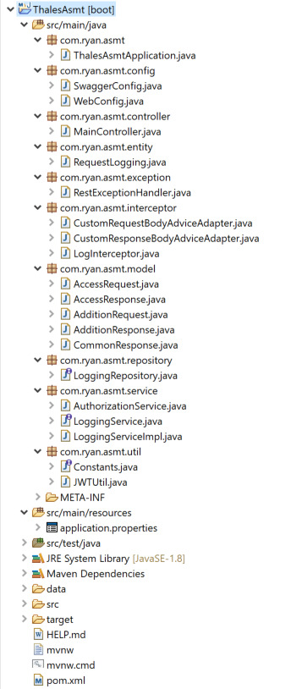

Database Configuration
I configure my Spring Boot application to connect an in-memory store with the username sa and the password sa. You may like to change those parameters in the application.properties file:
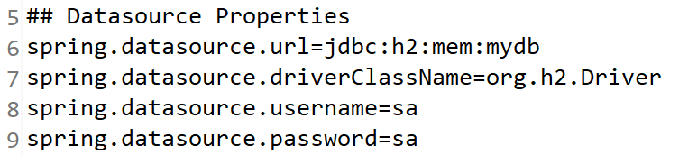
By design, the in-memory database is volatile, and data will be lost when we restart the application. We also can change to use the file-based storage by update the spring.datasource.url attribute.

Running Application
- You can import this project to Eclipse IDE or Spring Tool Suite, then run it as a Spring Boot App either with or without Debugging mode.
- Alternative, open Command Prompt and navigate to absolute path folder of the packaged Thales-Spring-Services.jar file. Run the following command (Java environment setup is required):
java -jar Thales-Spring-Services.jar
* Notes: I could not send the jar file over email, since it is about 45MB, and I also worry that your company’s mail server will block any executable file. I will upload to GitHub and share the link to you later. Sorry for this inconvenience.

Accessing the H2 Console
After starting the application, we can navigate to http://localhost:9001/h2-console which will present us with a login page. On the login page, we'll supply the same credentials as we used in the application.properties:
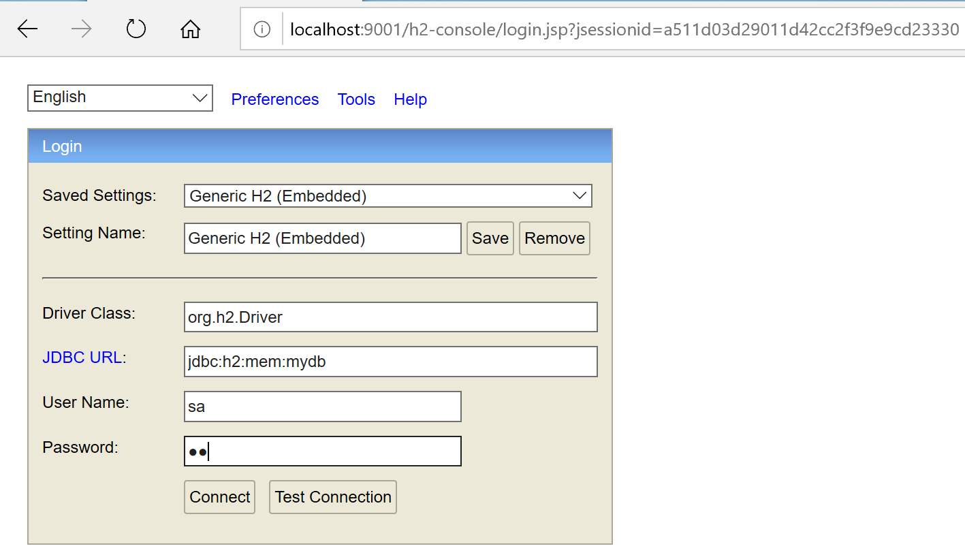
Once we connect, we'll see a comprehensive webpage that lists all the tables on the left side of the page and a textbox for running SQL queries:
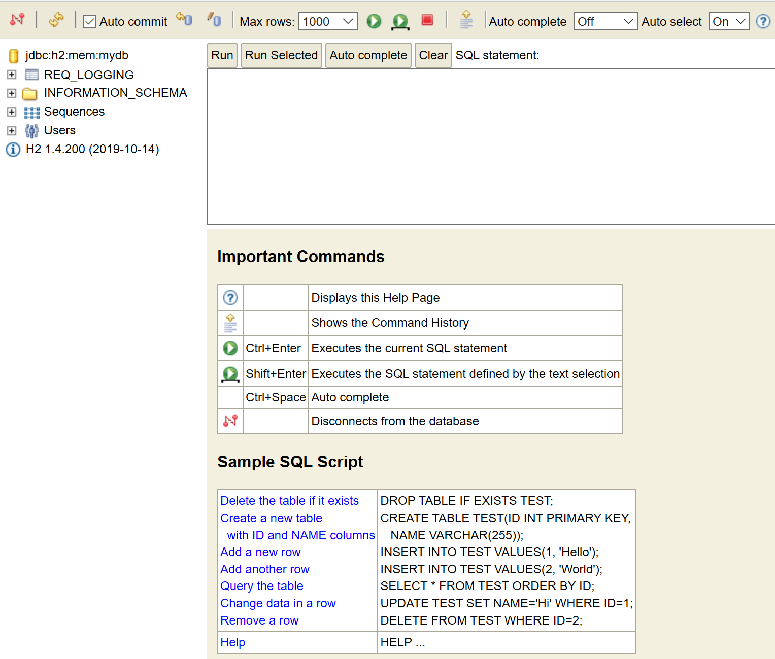

Global Exception Handler
I created a RestExceptionHandler class, extending from ResponseEntityExceptionHandler, and annotated with @ControllerAdvice annotation. This class helps to handle all exception specifics and global exceptions in a single place.
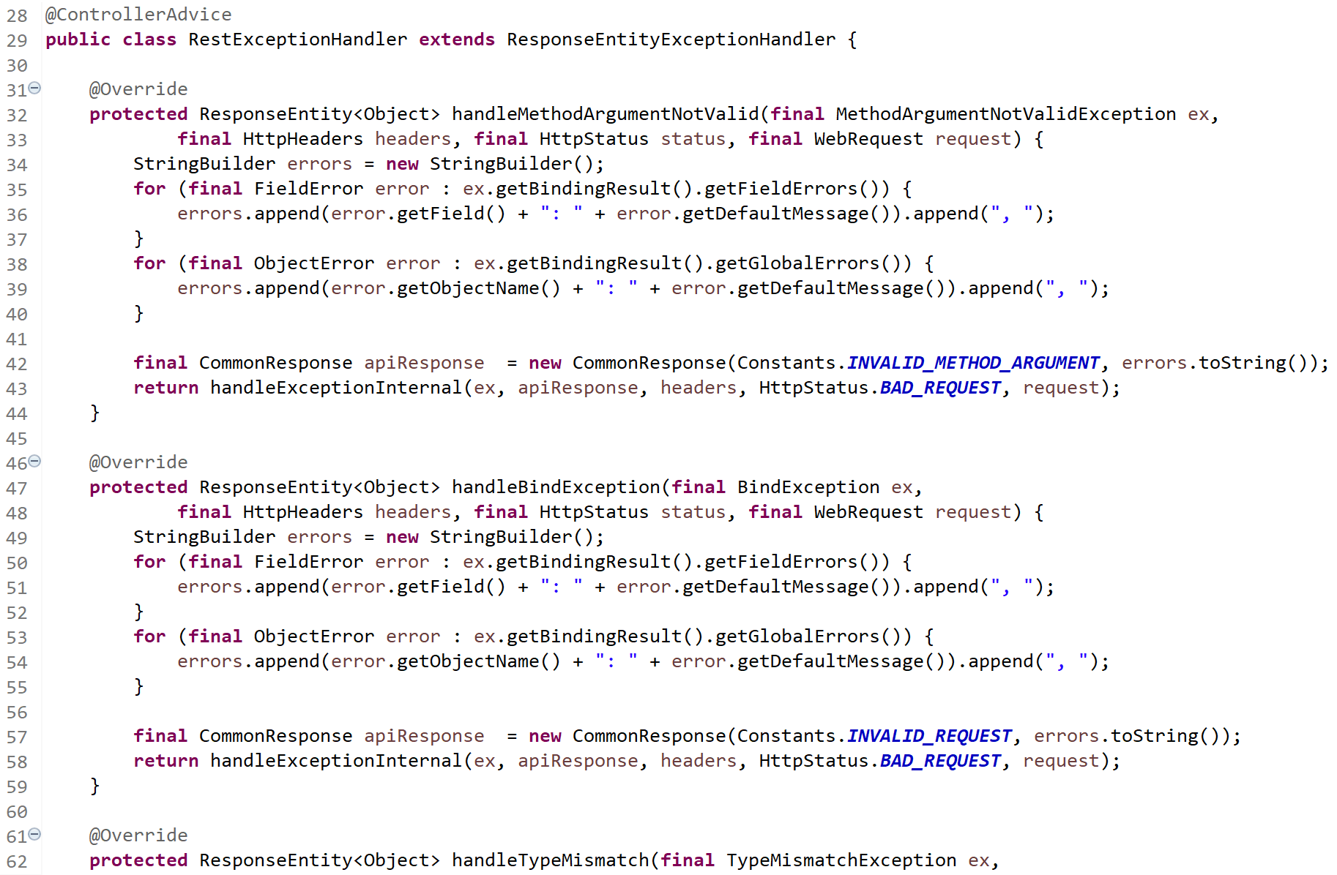

Testing REST APIs via Postman Client

Do Addition API:
HTTP Method: POST
Request URL: http://localhost:9001/api/v1/addition
Content-Type: application/json
Sample Request:
{
"num1": "-26",
"num2": "172"
}
Sample Response:
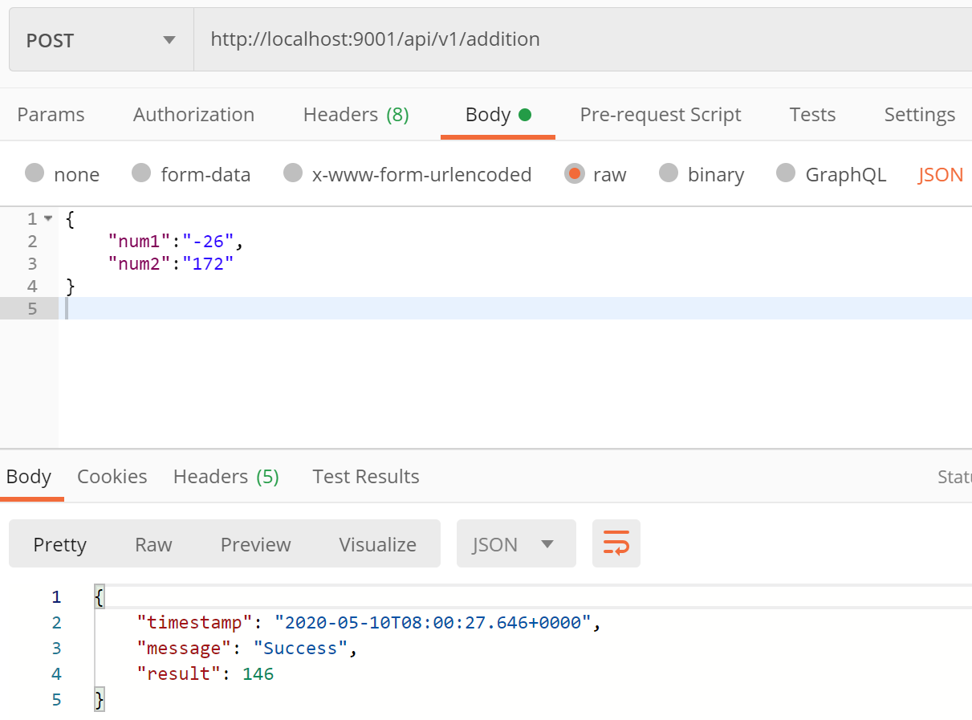

Verify User Access API:
HTTP Method: GET
Request URL: http://localhost:9001/api/v1/realms
Content-Type: application/json
Sample Request:
{
"username": "admin",
"password": "2020",
"organization": "thales"
}
Sample Response:
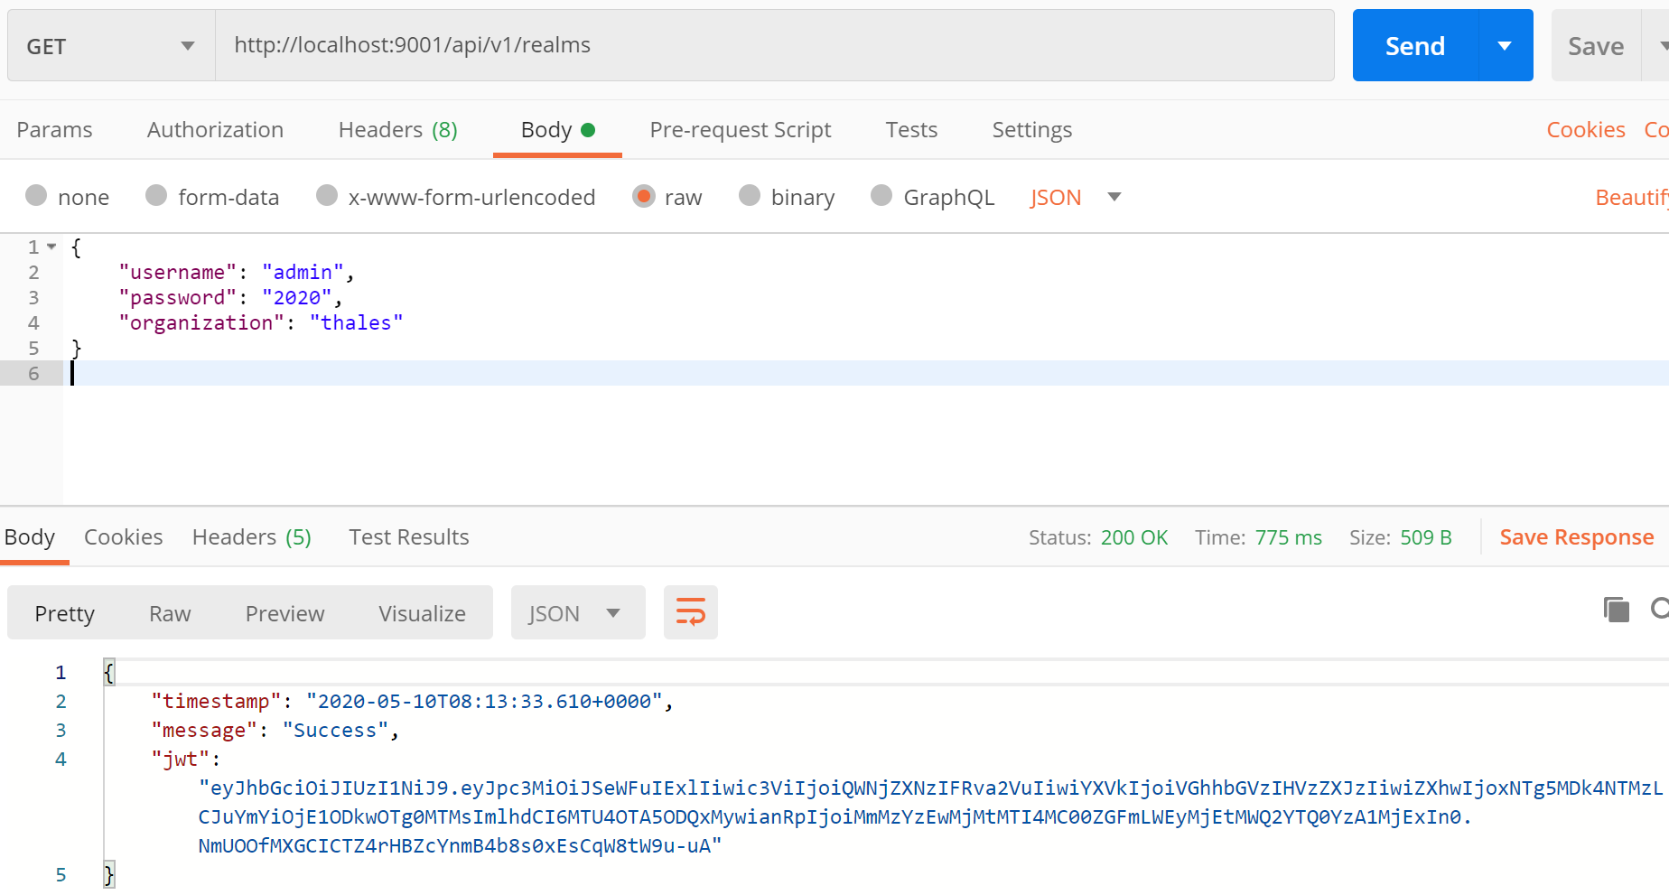

Get Loggings:
HTTP Method: GET
Request URL: http://localhost:9001/api/v1/logging
Content-Type: application/json
Request Header:
- Authorization: Bearer JWT
Sample Response:
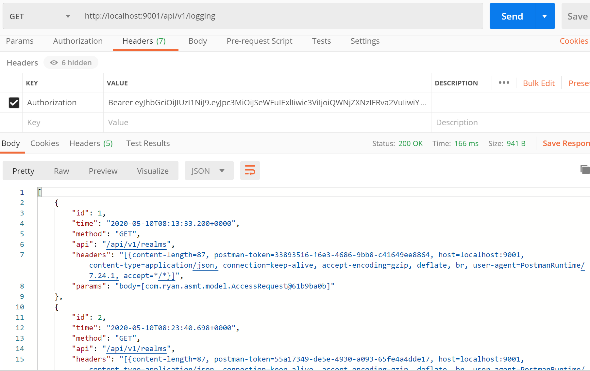

JWT Lifetime:
JWT token is only available in 2 minutes from the time it is generated. After it expired, user will encounter this error if trying to access by the same JWT:
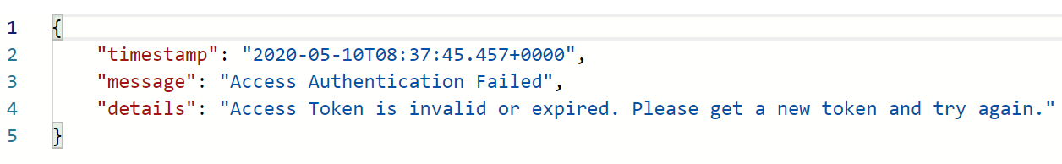
You can change this setting to increase/reduce JWT lifetime by update auth.jwt.lifetime attribute in application.properties.

